Researchers have spent decades to find out the features for a particular problem like for heart beat or speech recognition.

Features identified for heart beat won’t work for speech recognition.

But with the advent of Deep learning, if you have a lot of data, then deep learning model will automatically generate features called Deep learnt feature, and don’t need to find them manually for each problem.

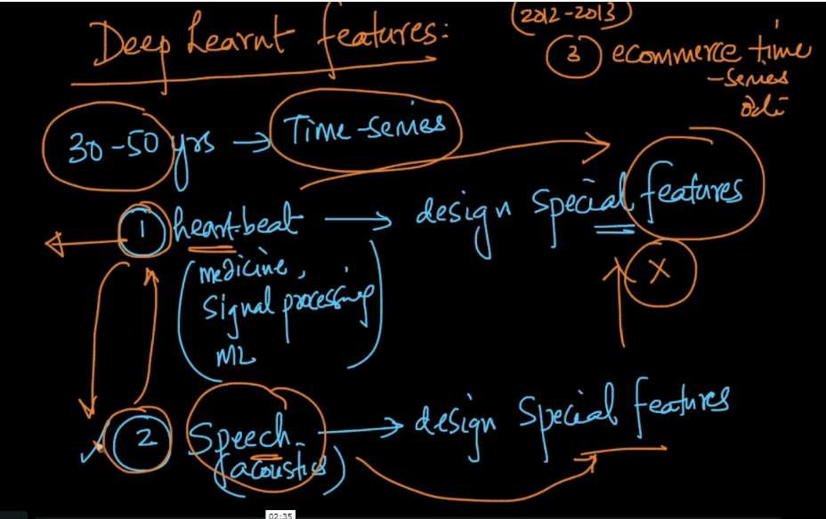

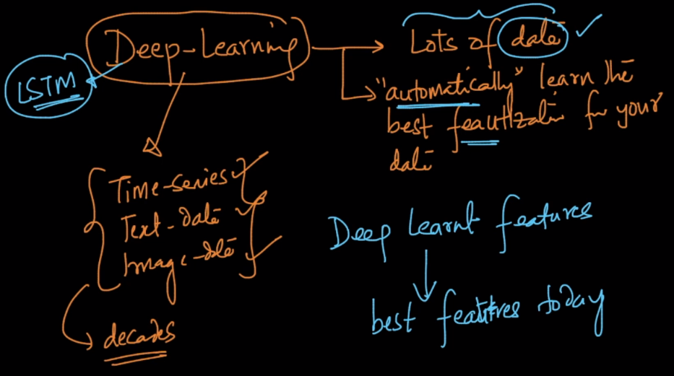

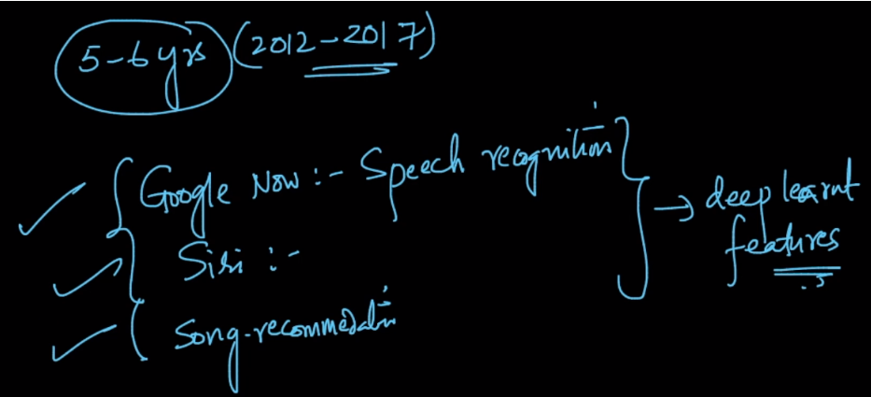

**Why deeplearning is not used everywhere:** <https://soundcloud.com/applied-ai-course/deeplearning-for-all-problems> .

